Seat Belt Sensor
Assembly Manual

Step 1. Load provided software onto a 32gb micro sd card using Balena Etcher.


Step 2. Insert micro sd card into micro sd card slot on Raspberry pi 4.
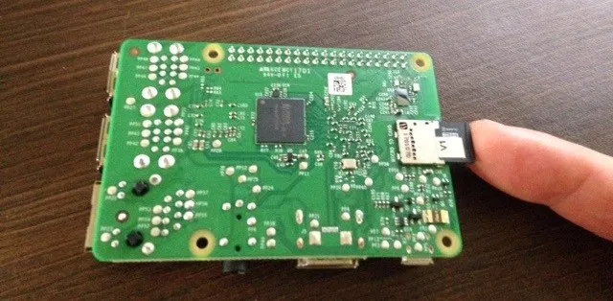
Step 3. Attach ribbon cable of IR camera into slot on Raspberry pi 4.
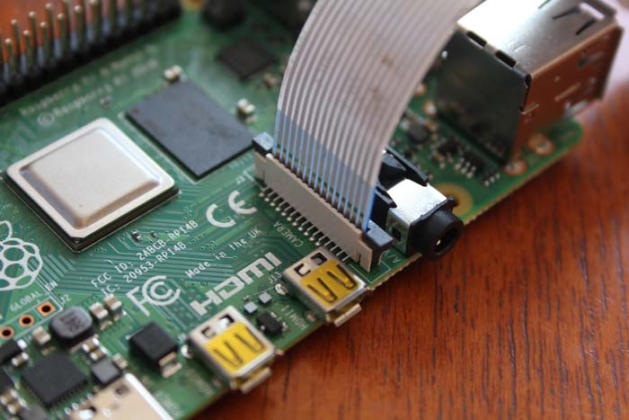
Step 4. Apply thermal paste on top of the CPU and fasten heat sink on top.
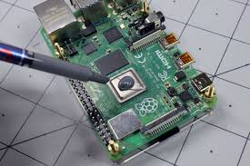
Step 5. Place Assembled Raspberry pi 4 into 3d printed enclosure.

Step 6. Plug in additional USB extension into open USB slot.
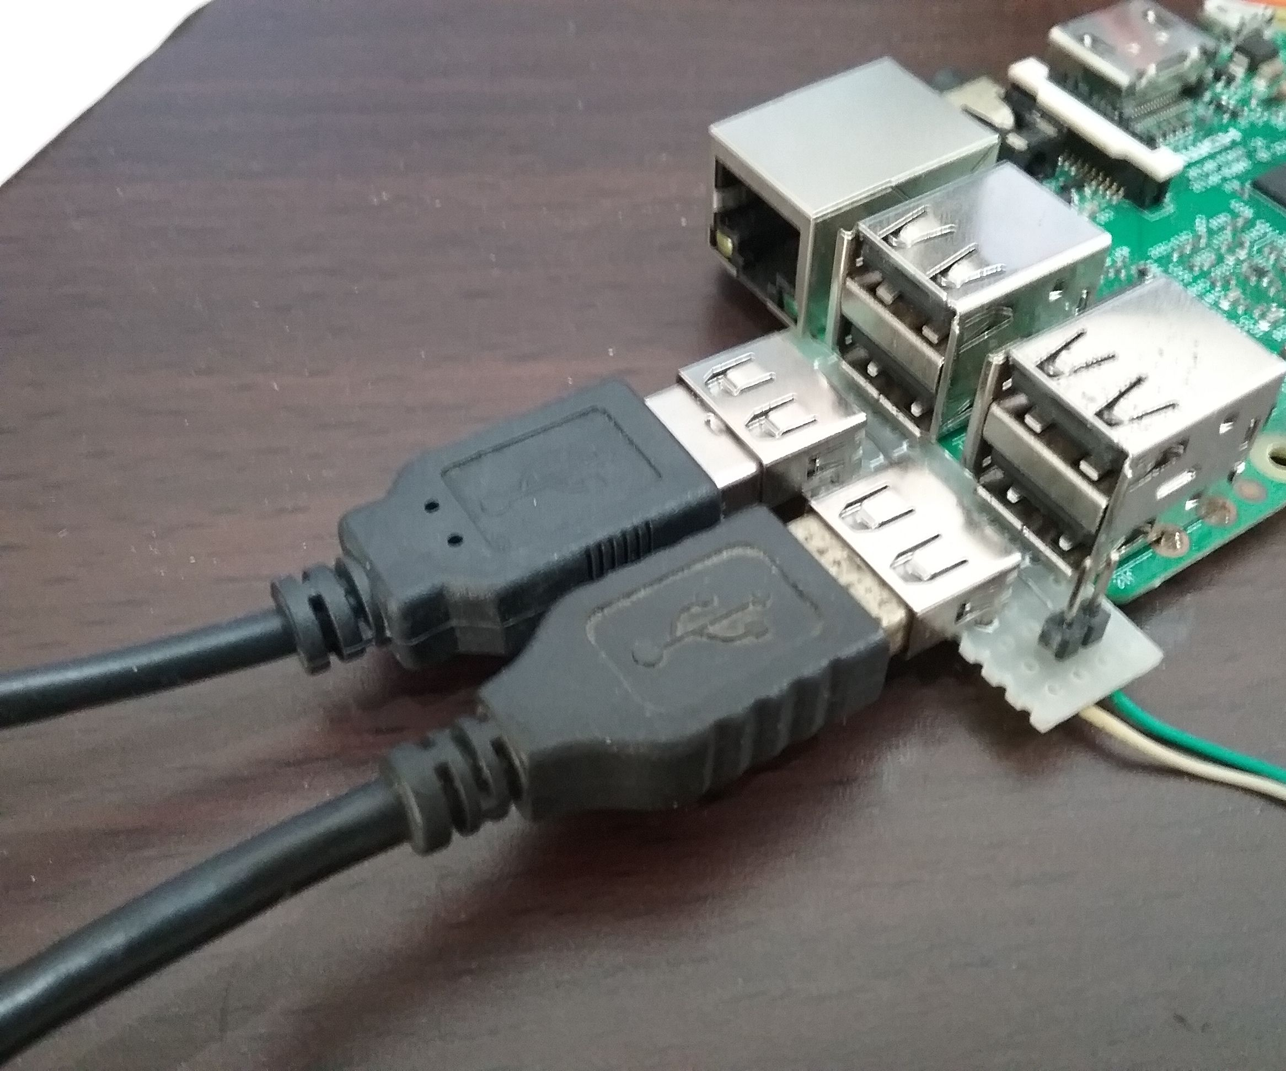
Step 7. Fasten the enclosure into the cab using mounting hardware.

Step 8. Using the mounting bracket, attach the camera mount in the viewing angle of the seat belt.

Step 9. Connect the USB connector to the USB extension cable and hide behind the trim.
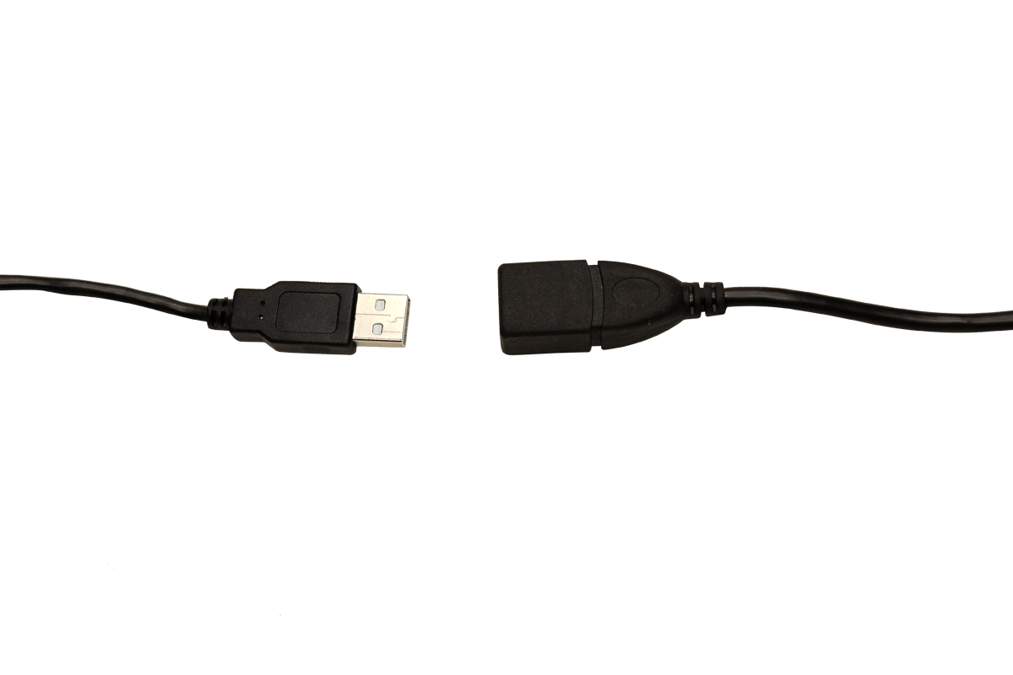
Step 10. Attach Relay with Raspberry pi.
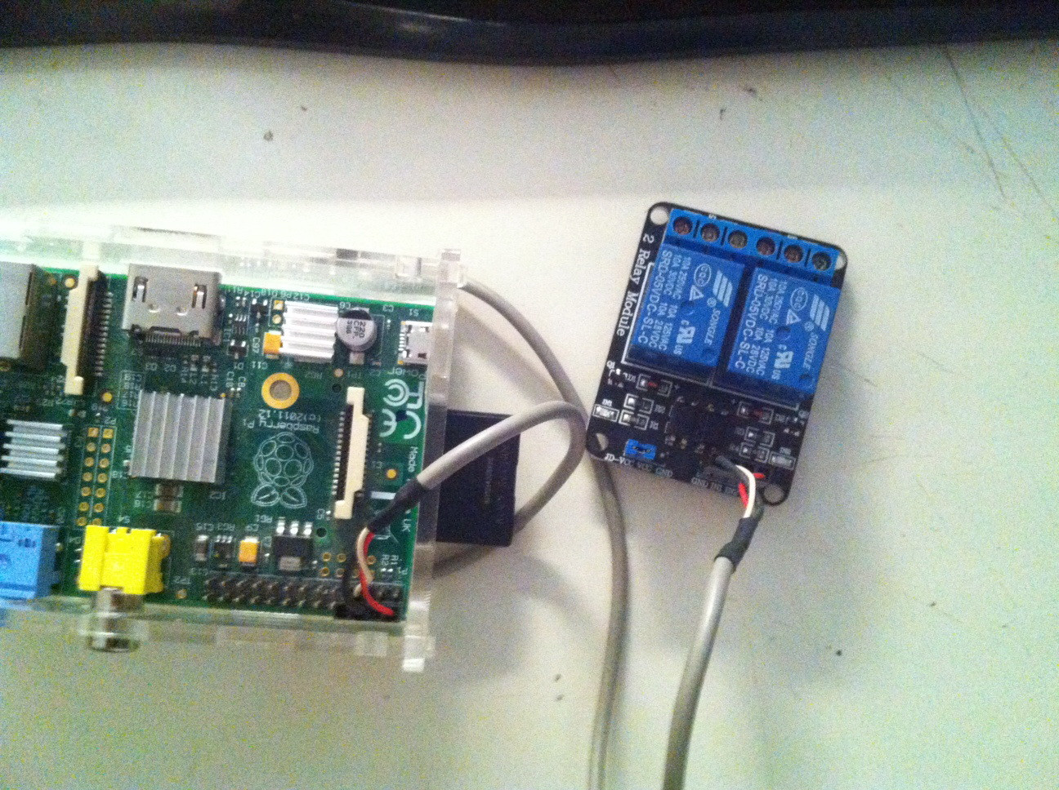
Step 11. Mount external strobe light onto optimal position of vehicle (varies).

Step 12. Run wire from strobe light to relay under the weather stripping of the door.

Step 13. Make wire connections.
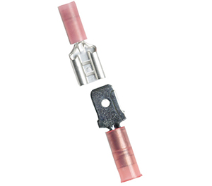
Step 14. Startup Raspberry pi 4.
